EX13-Create a Virtual Hard Disk and allocate the storage using VM ware workstation

PROCEDURE:

Step1: Create a virtual machine to add a new harddisk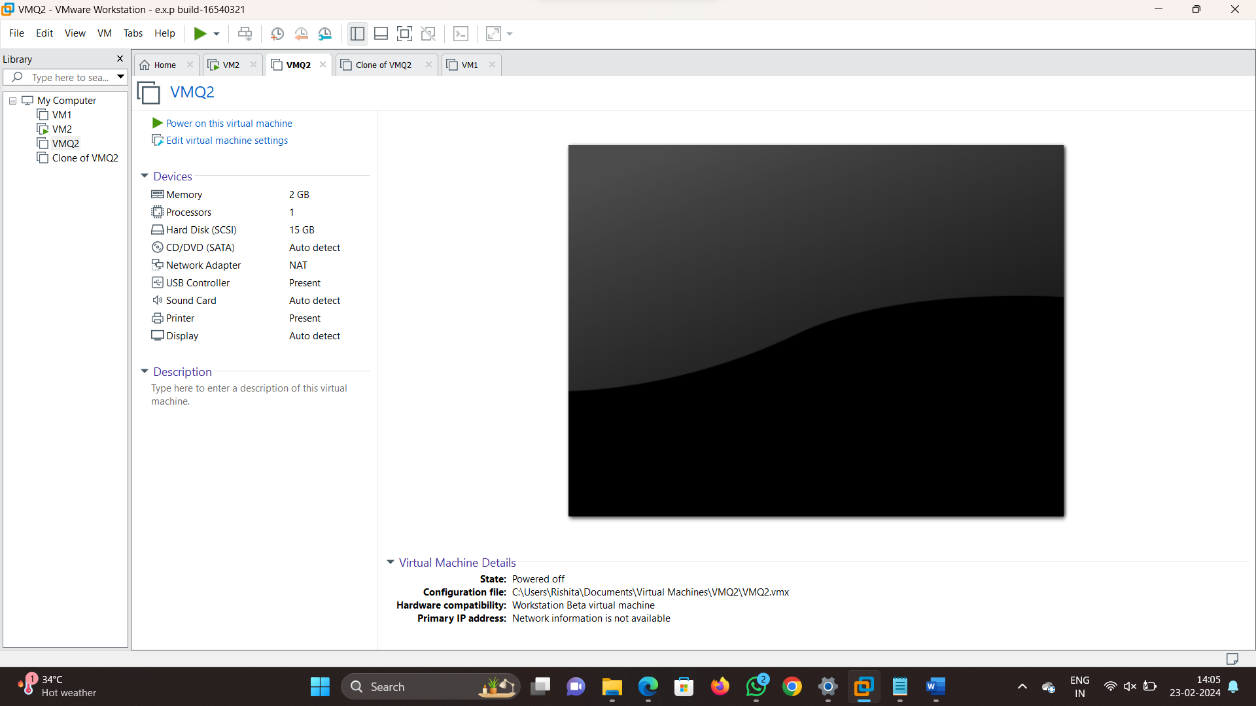

Step2: Now go to edit virtual machine and click on add and then click on harddisk

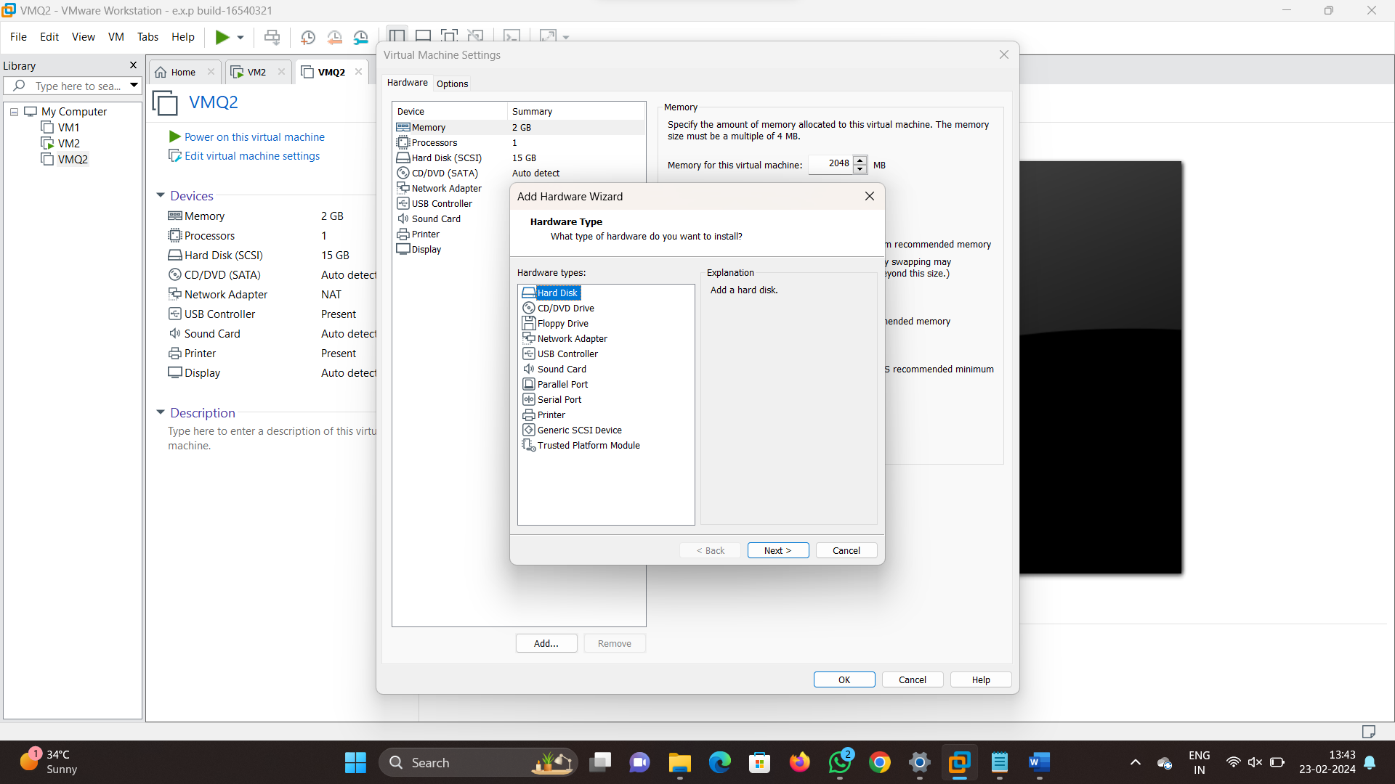

Step3: Now configure the harddisk storage as per required

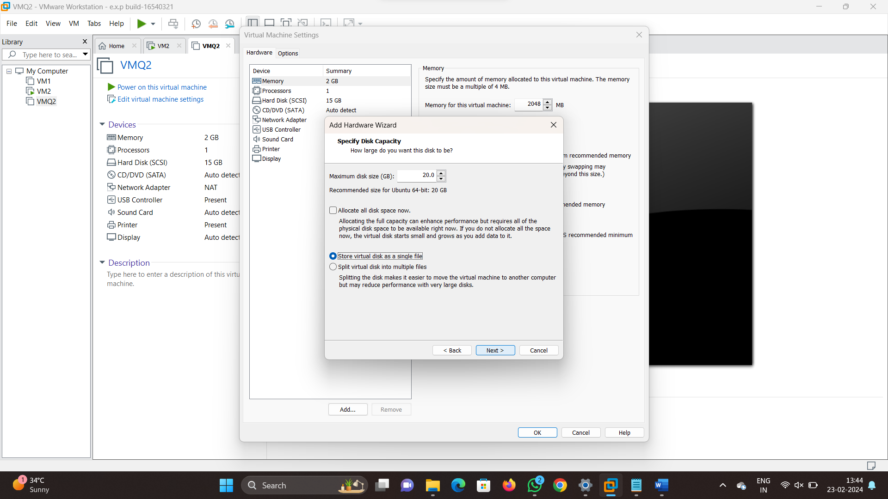

Step4: Now click on finish then we can see the added harddisk

